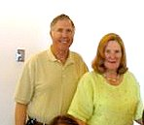
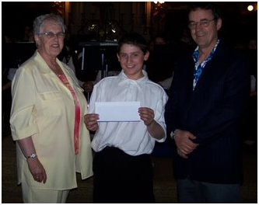
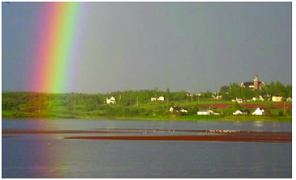
‘CONNECTING PEOPLE WHO CARE WITH CAUSES THAT MATTER”

Ten reasons people choose community foundations.
one
We are a local organization with deep roots in the community, and part of a nationwide movement whose support we build and share.
two
We bring donors to the table as community builders, working closely with them to align their philanthropic vision with the community’s needs.
three
We identify long-term needs and opportunities and invest in solutions that let our communities guide their own future.
four
We take a broad and inclusive view of what a community is, and provide grants to the widest possible range of organizations and initiatives.
five
We provide highly personal and flexible service, accepting a wide variety of assets and offering donors maximum tax advantage.
six
We build permanent funds and those that can respond to immediate needs, helping our communities ensure vital futures.
seven
We multiply the impact of gift dollars by pooling them with other gifts.
eight
We believe that diversity is strength, so we bring the entire community together to stimulate new ideas, build participation and strengthen community philanthropy.
nine
We are transparent and reputable stewards of community resources, committed to being accountable, accessible and responsive.
ten
We build community vitality – the unique and essential spirit that flourishes when people believe their community holds possibilities for everyone.

Community Foundation

for

Eastern Kings

When you establish an Unrestricted Fund, your gift addresses a broad range of local needs – including future needs that often cannot be anticipated at the time your gift is made. We evaluate all aspects of community well-being: arts and culture, economic development, education, environment, health and social services, neighbourhood revitalization, and more. The flexibility of your unrestricted gift enables your community foundation’s local experts to respond to the community’s most pressing needs, today and tomorrow.

SOURIS FUND

This endowment for the benefit of people in the Souris area was established in 2007. The Fund, made possible by a contribution from an anonymous donor has been invested as part of the Community Foundation portfolio. Earnings may be used for grants in support of any charitable activity in the Souris area. The Souris Fund is one of forty three endowments administered by the Foundation for the benefit of Islanders.

REAR ADMIRAL LOUISE C. and JAMES E. WILMOT SCHOLARSHIP

Rear Admiral Louise C. and James E Wilmot are citizens of the USA and long-time summer residents of Fairfield, Prince Edward Island. Wishing to contribute to the quality of life in their chosen community, and with a particular interest in health care, Louise and James Wilmot established scholarships for nurses in their area.

The purpose of the Fund is to improve health care in the Souris area through the provision of financial assistance to nurses in training on condition that, after completing their training and obtaining certification, they accept employment in the Souris Hospital for a period equal to the period covered by the scholarship. The introduction of this scholarship has sparked the interest of the Souris Hospital Foundation that has agreed to match the scholarship. Through the interest of the donors and with the help of the Souris Hospital Foundation, scholarship for 2009 and 2010 have been established for $2,000 per year for the last two years of study in Nursing. .


Souris & Area –
Undesignated Funds
SOURIS FUND
RECIPIENTS

2007
Souris High School Band

2008
Harbourview Training Centre

2009
Souris 4-H District Council – Dundas Exhibition

Rear Admiral Louise C. and James E. Wilmot Scholarship
Recipient

2009
Melanie Larkin
More benefits
Funds established at the Community Foundation must comply with the regulations laid out by the Canada Revenue Agency. The only way that funds can be disbursed by the Community Foundation is through a charitable organization, educational institution or a municipality.
It is through a fund such as the Souris Fund that that area needs can be identified and assistance provided through a grant as recommended by the organizing committee.
A fund can easily be established to provide funding to assist in the maintenance of a historic building or structure in the community.
The investment and granting policy of the Community Foundation are integrated and designed to provide a grant that grows with inflation. All investment income is not granted as earned. A portion of the investment income is added to the investment which in normal times, allows the fund value to grow. The amount granted is equal to 4% of the 4 year rolling average of the fund value.

Questions or information on the Souris Fund can be directed to either Carol Fraser (current CFPEI Director) or Margaret Ching (former CFPEI Director).

Board of Directors

John Robinson
Tom Davies
Joyce Gaudet
Tracey Laughlin
Norman Carruthers
Heather MacDonald
Donald Glendenning
Lou Ann Thomson
David Anderson
Rogers Bell
Steve McQuaid
Carol Fraser

The Community Foundation of Prince Edward Island is dedicated to improving the quality of life for all Islanders. We are a local organization with deep roots in the community, however we are part of a nationwide network, one of 168 in Canada.

With the establishment and management of funds gifted in perpetuity, The Foundation distributes the earnings for any charitable purpose including human services, arts and culture, education, environment, religion, and health and physical activity.

If you require information, feel free to contact any director or contact us at:

The Community Foundation of Prince Edward Island
Suite 105, Queen Square Center
119-121 Queen Street
Charlottetown, PE CIA 4B3

Telephone: (902) 892-3440; Fax: (902) 892-0880
Email: foundation@cfpe.ca
Web site: www.cfpei.ca

